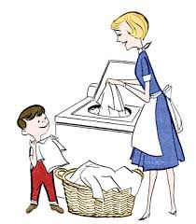
All this my mum does for me.
Number the pictures.

1. She cares for me when I am sick.
2. She reads stories to me.
3. She feeds me.
4. She washes my laundry.
5. She cooks my favorite food.
6. She makes my bed.
7. She cleans my room.
8. She puts me to bed.
9. She kisses me.
10. She plays with me.
11. She hugs me.
12. She comforts me.
13. She brings me to school.
14. She helps me with the homework.
15. She goes for a walk with me.
16. She wakes me up.

