Lesson subject: Travelling and tourism – my blog.
Target group: Senior years
Nr of lessons: 5
Equipment: computers/students’ smartphones
Lesson objectives, students:
- Revise narrative tenses;
- Learn vocabulary connected to tourism and travelling
- Learn how to create blog;
- Practise writing in English,
- Become more motivated by working with technology and practising writing real blogs.
Lesson 1
Revision of narrative tenses: Past Simple, Past Continuous, Past Perfect. Teacher explains theory, gives examples, etc. students do exercises.
Lesson 2
Students learn how to create touristic blog. Teacher familiarises students with program called Wordpress. Students create their accounts on https://wordpress.com. After creating the accounts, guided and supervised by teacher, students create their own blogs: name them, add descriptions, choose a subscription. Finally, they personalise their blogs – choose colours, motives, add photos, etc.

Instruction how to use Wordpress and create a blog below.
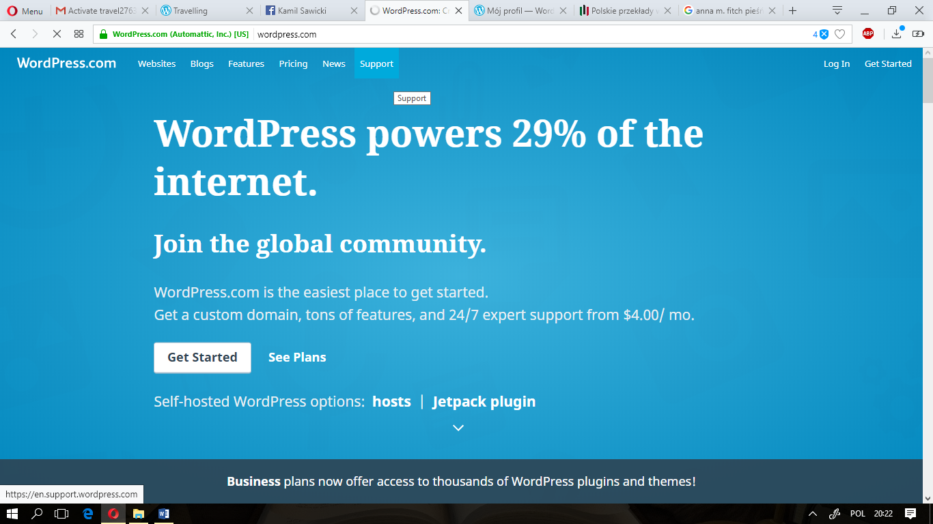

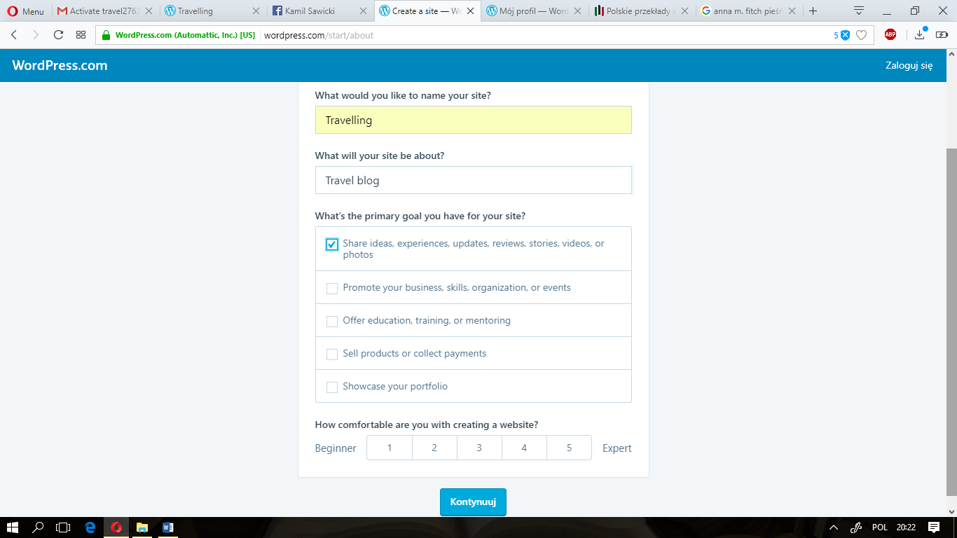
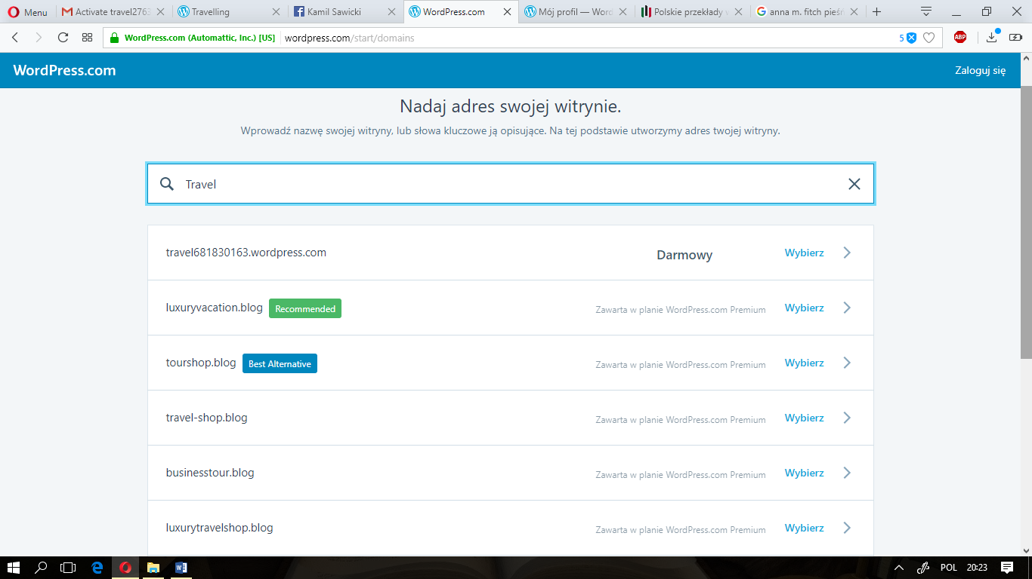
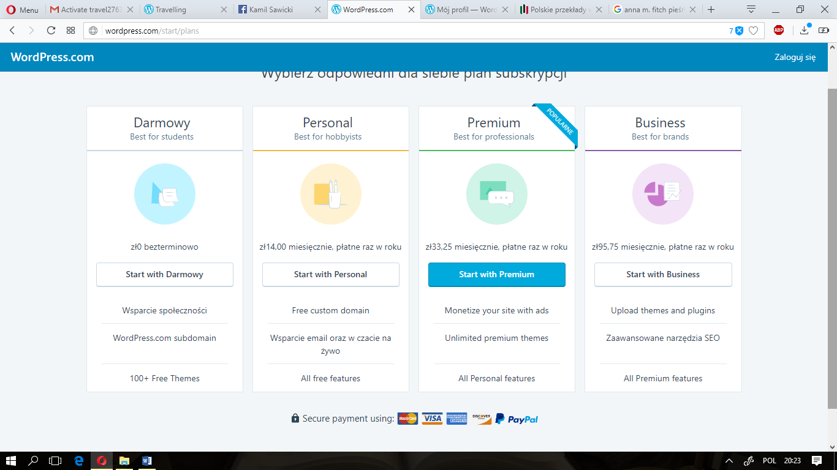
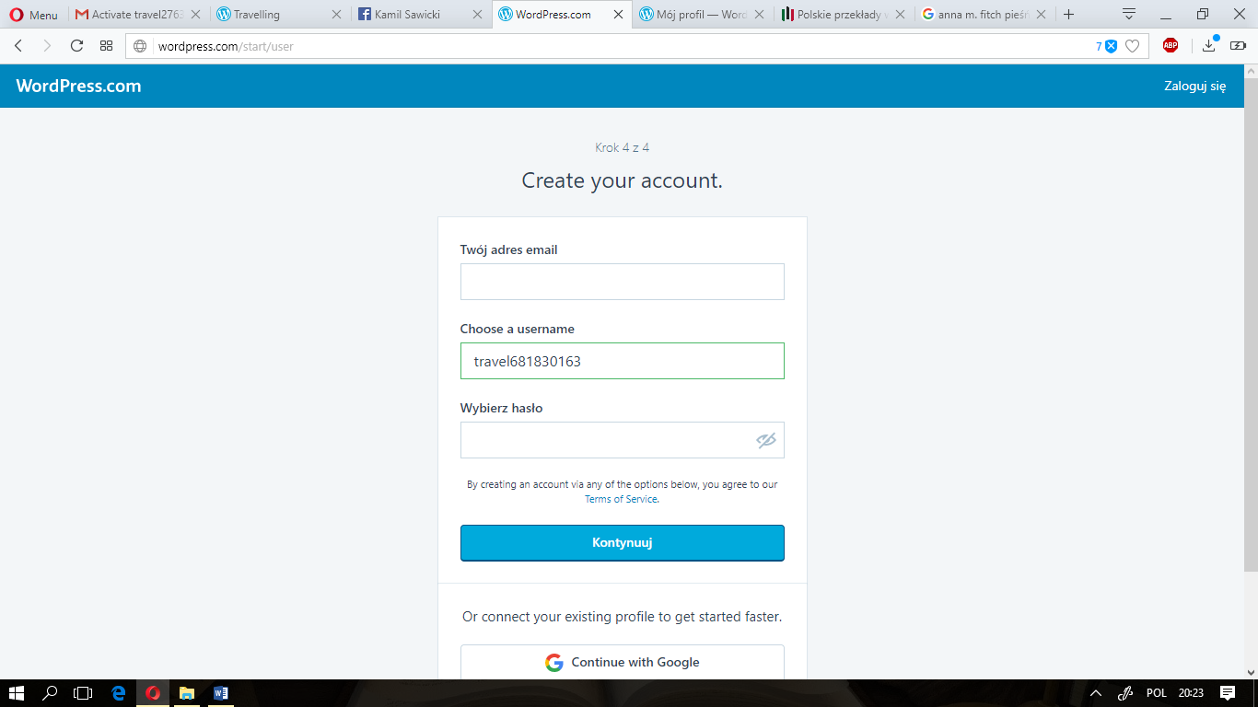
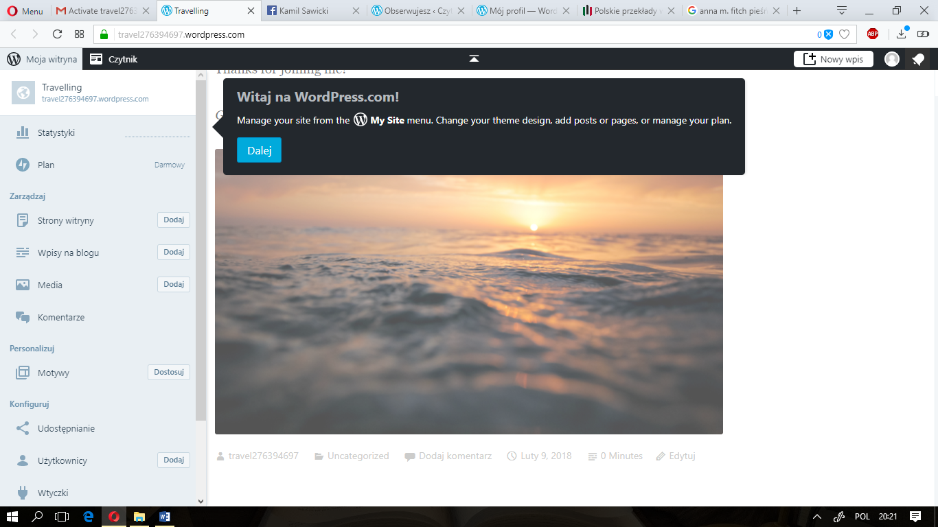

Lesson 3
Students are doing “Travelling and tourism” unit in their course book. During first lesson students get to know vocabulary connected to accommodation means of transport. Then, they write first part of their blogs:
During last holiday you were travelling round Europe. On your blog:
- Write about means of transport you used during the journey
- Write which means of transport you recommend and why
- Describe at least two places you were staying at
- Say what kind of accommodation you recommend and which one you advise against.
If there is not enough time to finish the blog during the lesson, students finish it at home.
Lekcja 4
During the next lesson, students learn vocabulary connected to sightseeing and accidents/problems which might happen while travelling. After that they write next part of their blogs:
During winter break you went abroad. On your blog:
- Write where you went and why you had chosen this country
- Describe places/monuments you visited and say which one you liked the most
- Describe a difficult situation that happened to you and how you dealt with it
- Say how you are going to spend the rest of your winter holiday.
Lesson 5
Revising and remembering the vocabulary and narrative tenses. After assessing the blogs and giving students appropriate feedback, students present their blogs to the rest of the group.

